**P. G. Department of Political Science**

**A. S. College, Khanna**

**Session 2024-25**

**Departmental Achievements**

1. On 17th August 2024, to celebrate World Humanitarian Day, the department organised essay writing competition on the topic, Violation of Human Rights Is A Threat To Humanity. Out of 10 participants, Mr Harshil Sharma of M.A. Sem Ist, Political Science and Miss Tanishjot Kaur of BA Sem Vth bagged first positions, Miis Liza from B.A. Sem IIIrd got second position and Miss Simranjit Kaur of M.A. Sem Ist political science won third position.

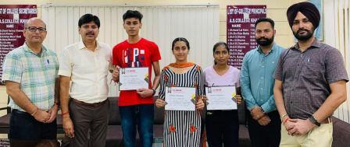

1. On 21st September 2024, to celebrate International Day of Peace, the department organised a speech competition on the theme, Cultivating A Culture of Peace. Out of 8 participants , Miss Tanishjot Kaur from BA 5th Sem, Miss Sareena from M.A Sem IIIrd Political Science and Simran Kaur from M.A. Sem Ist political science bagged first,second and third positions respectively.

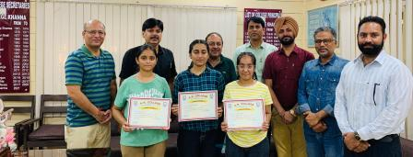

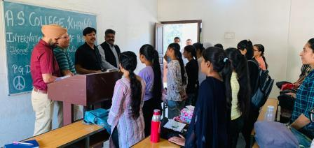

1. Miss Manpreet Kaur, a brilliant student of MA Sem first Political Science was selected in Punjab Police.

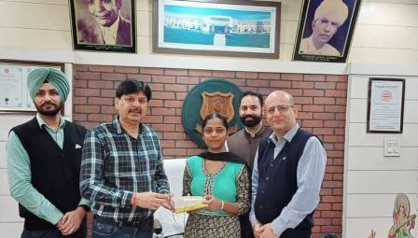

1. To celebrate 15th National Voter Day ,on the theme, Nothing Like Voting , I Vote For Sure, the department organised a series of activities
2. Poster Making Competition was organized on 16th January, 2025 in which Student of M A Political Science Babita Verma bagged first position , Dilpreet Kaur , Second, and Simranjeet Kaur and Ramanpreet Kaur both bagged the third position.
3. 93 students of Political Science from post-graduate and under-graduate classes participated in the online Quiz competition held on 19-01-2025, which was organised by Chief Electoral Officer, Punjab and the participants received E Certificates.
4. On 20- 01-2025, a pledge ceremony was conducted in which faculty members and 45 students participated. Miss Amandeep Kaur , student of M A 4th Sem political science administered the oath.

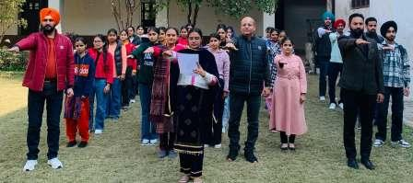

1. On 25-01-2025, a speech competition on the topic "Right to Vote: A Cornerstone of Democracy" was organised. Out of 8 participants , Jasleen Kaur of B A Ist bagged first position, Manjot Kaur , B A IInd year on second place and Tanishjot Kaur of B A final year and Navjot Kaur of B A I st bagged the combined third position.

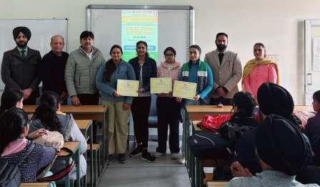

**Individual Achievements of Faculty Members**

**Prof. Gagandeep Sethi**

**Member board of Studies**

1. Nominated as a member of Board of Studies in Gandhian and Peace Studies, Panjab University, Chandigarh

2. Nominated as a member of Undergraduate Board of Studies in Political Science, Panjab University, Chandigarh

**Extension Lecture**

On 20-11-2024, delivered a Guest Lecture on “Dr. Amedkar and Indian Constitution” at RSFF Govt. Sen Sec. School, Amloh Road, Khanna. The event was organized by Dr. B.R.Amedkar Mission Society, Khanna

**Paper Presentation**

Presented a Paper titled “The Role of Municipal Council Khanna in Sustainable Development” in Two Days National Seminar on “Role of Education, Humanities and Social Sciences in achieving Sustainable Development Goals in India” held at RIMT University on Nov 22-23, 2024

**Dr Inderjit Singh**

**Member of Board of Studies:-**

1. Presently appointed as Member of Board of Studies for PG and UG Classes, P.G. Department of Political Science, Mata Gujri College, Fatehgarh Sahib from the Sessions of 2023 to 2026.
2. Presently appointed as Member of Board of Studies for UG Classes, Department of Public Administration, Mata Gujri College, Fatehgarh Sahib from the Sessions of 2024 to 2026.

**Paper Presentation:-**

Presented a paper "***Political Participation of Women in India: An Analysis"*** in **15th International Conference** on **"Empowering Women For A Sustainable Future"** organised by Women’s Studies Centre Punjabi University Patiala on 23rd April 2024.

**Guest Lecture:-**

Delivered a guest lecture on the topic "Contemporary Challenges to Human Rights" at the Department of Political Science, Sri Guru Granth Sahib World University, Fatehgarh Sahib on 09/10/2024.

**Faculty Induction Programme:-**

Attended 132nd Faculty Induction Programme from 29-11-24 to 26-12-24 organized by the UGC-Malviya Mission Teacher Training Centre, Panjab University, Chandigarh.